Python runs on an interpreter system, meaning that code can be executed as soon as it is written. This means that prototyping can be very quick.
Python can be treated in a procedural way, an object-oriented way or a functional way.

It was created by Guido van Rossum in 1991 and further developed by the Python Software Foundation. It was designed with an emphasis on code readability, and its syntax allows programmers to express their concepts in fewer lines of code.

The Python interpreter is easily extended with new functions and data types implemented in C or C++ (or other languages callable from C). Python is also suitable as an extension language for customizable applications.

Python supports multiple programming paradigms, like object-oriented, imperative and functional programming or procedural.

- language features:
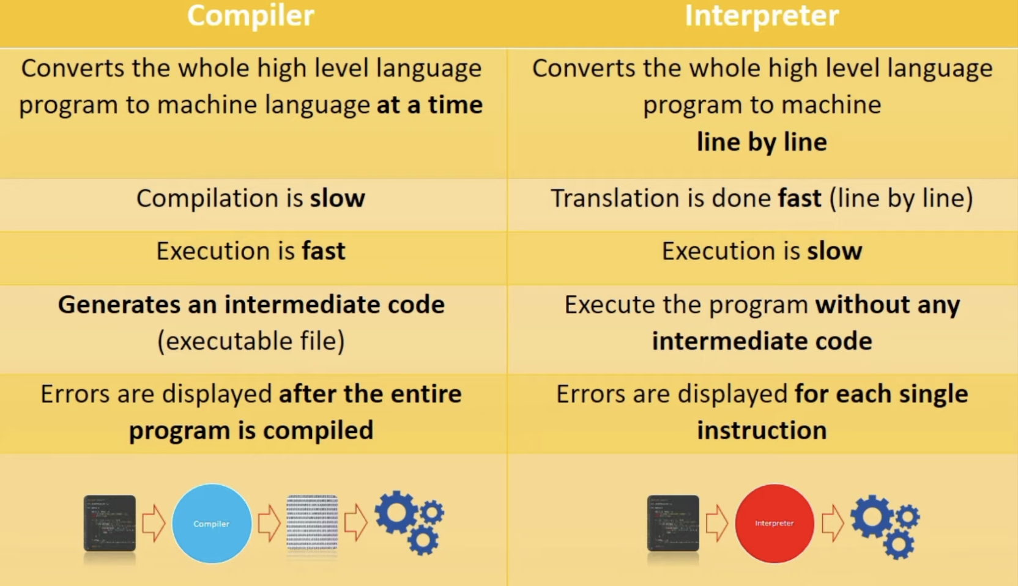

One popular advantage of interpreted languages is that they are platform-independent. As long as the Python bytecode and the Virtual Machine have the same version, Python bytecode can be executed on any platform (Windows, MacOS, etc).

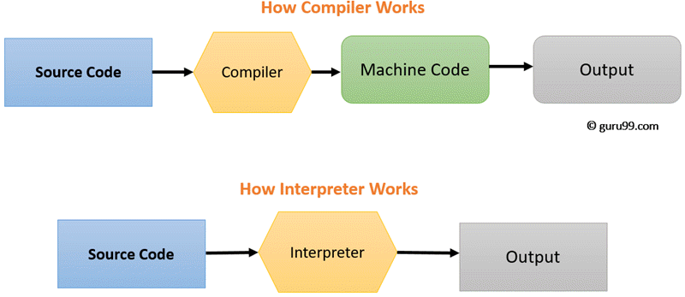

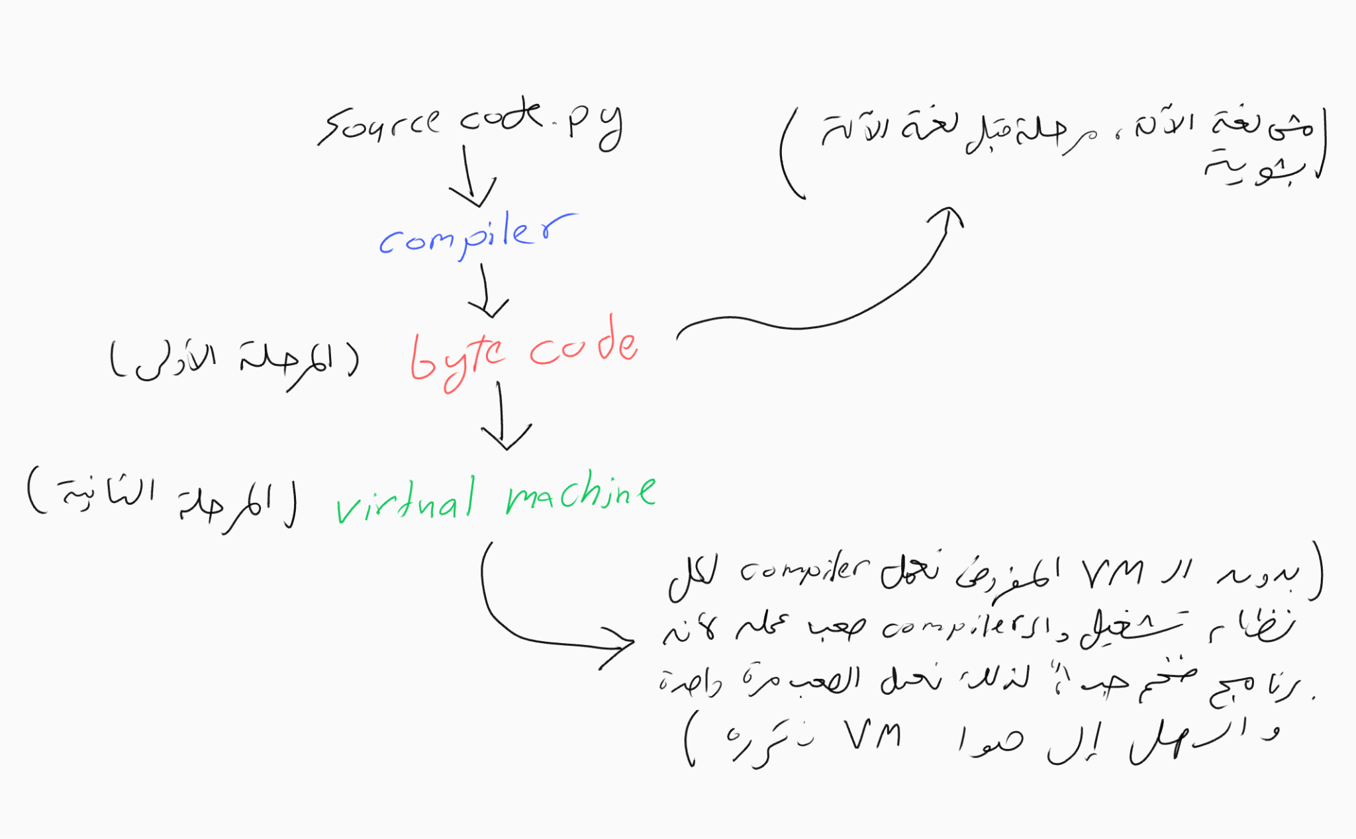
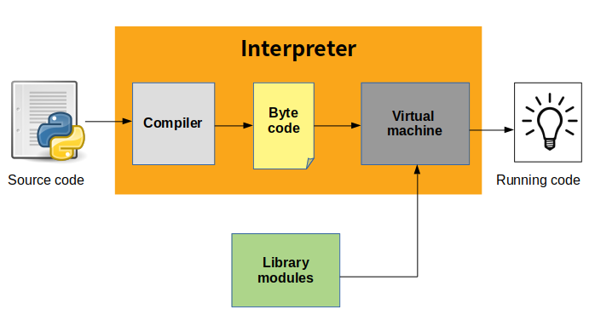
- built-in data types in Python:
- Binary Types: memoryview, bytearray, bytes.
- Boolean Type: bool.
- Set Types: frozenset, set.
- Mapping Type: dict.
- Sequence Types: range, tuple, list.
- Numeric Types: complex, float, int.
- Text Type: str.

